

Affiliated to the

Incorporated Association

Of Organists

**August 2024**

**Last issue April 2024**

**Diary Dates 2024**

17th August, 2pm Treasure Hunt

25th Sept, 7:30pm Composite Recital & BDOCA AGM – All Saints, Foots Cray

5th October 5th , 5pm BDOCA Singers Evensong

Venue TBA

**Please do support these events - the more the merrier!**

Inside this issue:

Diary Dates 1

Treasure Hunt 1

BDOCA AGM 1

BDOCA Singers 2

New Member 2

Website 2

Bursary 2

Hand Bells Report 2

Evensong Report 3

Cathedral Chorister Report3

Tony Holcroft Obituary 4

Your committee 5

**Treasure Hunt**

Saturday 17th August

This will be in rural Shoreham, Kent and we will be able to meander around the village and then gather in the church to see and hear the organ – part of which may date back to the early 18th century.

Please meet at 2.00pm in the entrance porch to the parish church of St. Peter & St. Paul - TN14 7SB – not at the gate. We request a donation of £1-50 for each quiz sheet.

We can picnic in the church grounds, go to the loo, and make cups of tea there - thanks to the kindness of the vicar and congregation. We can even use a room in there if the weather is inclement. There are also two pubs which serve meals, if you don’t wish to picnic.

Please let Melvyn know if you wish to attend.

Please also let Reg. know **ASAP** if you wish to book for dinner at a pub rather than have a picnic.

**BDOCA AGM**

**Wednesday 25th September, 7:30pm**

AGM with members’ recital at the start and light refreshments after.

All Saints’ church, Foots Cray.

Please let Reg. know by 18.8.24 if you can take part in the composite recital at the start of the AGM.

Please supply the composer, title and timing.

**BDOCA Singers Membership**

The BDOCA Singers are keen to increase membership. The SATB choir was formed in 2018 and first sang Evensong in March 2019. The proposal at that time was to sing Choral Evensong 2-3 times a year at various churches in the area with 4-5 rehearsals in the preceding months. The pandemic interrupted this somewhat, but the choir resumed in 2022 and the Evensong at St Mary’s, Welling, in October was the second such service given in 2023 (report later in this issue). In order to continue to enjoy a varied and interesting repertoire, the choir needs to grow. Rehearsals are held at All Saints’ church, Foots Cray. Singers do not have to be BDOCA members and there is no subscription fee other than a small donation for the church at each rehearsal, so please spread the word.

**Page 2**

**New Member**

We welcome Dean Humphreys who recently joined BDOCA. He is a member of St Paulinus choir, Crayford, and regularly sings with the BDOCA Singers.

**Website**

In conjunction with Alan Hunt (who has kindly run our website for many years), Aeron has updated it. Aeron now invites contributions and also needs to update the “available to deputise” information.

Your contributions will be very welcome.

**Bursary**

BDOCA is keen to encourage youngsters to learn the organ and will give sympathetic consideration to requests for financial support. Please write to Melvyn with your request and supply supporting details.

**‘Hand Bells afternoon’ report (11th May)**

When BDOCA organised the first handbell ringing afternoon a couple of years ago I have to admit that I wasn’t really looking forward to it but went out of a sense of duty – but to my surprise this was a really enjoyable afternoon. And so, this year, when the second session was arranged, I signed up straight away. It is amazing how people who spend their Sundays using both hands and both feet making sounds out of a large instrument while at the same time using the same hands to change registrations, turn over pages etc while looking in a mirror to see what is going on at the other end of a church – can find it so difficult to ring one handbell at the right time. At the first session after a few attempts we were given two bells each – which means identifying two different notes and shaking the correct bell at the correct time. The lady who is in charge obviously took note of our previous ability as this time we were only given one bell each. On some occasions playing was halted as we were all laughing too much.

Thanks to Melvyn for arranging everything and hosting at his church. Next time I hope even more members will come – either to participate or perhaps to watch, with a prize for the audience member who spots the most mistakes.

Peter Mitchell

**‘BDOCA Singers Evensong’ Report**

Despite a very wet late afternoon - Saturday 27th April saw a small congregation gather at the ancient and grade II listed church of St. Paulinus, Crayford for Choral Evensong to be led by our own BDOCA choir.

The choir nicely robed were seated in the choir stalls which are located at the rear of this church.

Under Reg.’s steady direction the service started with the introit *Now The Green Blade Riseth* by the well known English composer - Martin Shaw. The service was led by Fr. James Butler, their recently arrived curate with a good singing voice.

The *Preces and Responses* were by Thomas Ebdon. [ (1738–1811) a British composer and organist born in Durham.]

Following Psalm 84 and the readings the choir in good voice sung the *Magnificat and Nunc Dimittis* by Derek Holman (19th /20th century composer born in Cornwall).

The choir of some fourteen singers, nicely sang the anthem by Walford Davies – *O sons and Daughters*.

We then had the chance to join in and sing along with the Office Hymn – *Most glorious Lord of Life*. (Henry Lawes).

An enjoyable choral evensong and it was good to hear a firm, steady and balanced tenor and bass lines underpinning the pieces.

We joined together in the grace and were then able to reflect on the service as Peter Mitchell played a delightful piece (Psalm19) by the 15th century Italian composer Benedetto Marcello (arranged by Hopson).

Thank you Reg. and all choir members for helping to continue the good English tradition of Choral Evensong which helps us reflect on God’s glory with the help of some wonderful music.

Melvyn French

**Page 3**

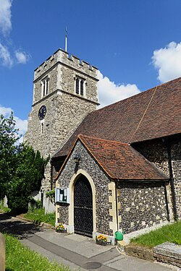

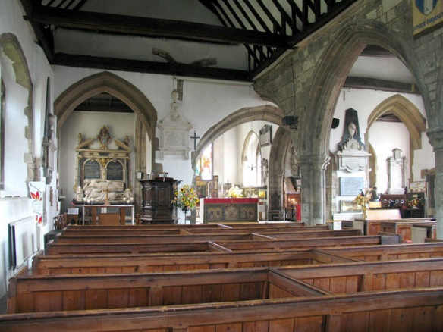

**‘Life of a Cathedral Chorister’ Report**

On the evening of Wednesday 24th July, we met at St John’s Church, Bexley to hear from the Team Vicar, the Rev. Edward Barlow, about his experiences as a chorister at Manchester Cathedral.

He was a member of the “vollies”, or voluntary choir, as opposed to the main rank of “statutory” choristers.  It was interesting to learn about the way younger choristers were mentored by the senior choristers, through an approach akin to the old apprenticeship model, and how choristers progressed through the ranks.

Cont ….

…..cont.

We gained not only an insight into the life of the cathedral itself, but also a fascinating snapshot into the history of the wider church and the city in the 90’s, and the role that the cathedral choir played in that.  In 1994, Rev. Barlow was present with the choir at the first ordination of women in the Church of England; due to the controversy surrounding this event, St Philip’s Church in Salford hosted the service.

Another momentous event in Barlow’s time as a chorister was the IRA bombing on nearby Corporation Street in 1996.  The cathedral had an important pastoral role in the city in the years following the bombing, as the city centre was rebuilt; the choir contributed greatly to this role, particularly in civic services to celebrate the rebuilding work.

We are very grateful to Rev. Barlow for his warm welcome to St John’s, and for his engaging and wide-ranging presentation.

Aeron Preston

**Page 4**

**Tony Holcroft Obituary**

7th May 1941 – 29th December 2023

*Well done Good and Faithful Servant*

Tony, or Anton, as he was called by his family, was born in Salisbury on the 7th May 1941 to William and Gertrude Holcroft. He grew up in Durrington, a village near Stonehenge, with his younger brother Adrian. At the age of seven he was recognised by the music teacher at his junior school as having a remarkable gift for music and subsequently passed a scholarship to Salisbury Grammar school. The school had a chapel and Tony sang in the chapel choir and at the age of 14 he was given the opportunity to have flute lessons.

On leaving school he spent a year teaching at a private school near Cheltenham and then decided to train to become a music teacher at Goldsmiths college. After graduating he was invited to play with various well-known orchestras but decided against being a full-time musician.

In the early 1960s, Tony moved to Bexleyheath and started his career teaching music in a secondary school in Crayford. He continued to play the flute with the orchestra at Goldsmiths and became a member of the congregation and choir of Christ Church Bexleyheath.

Tony moved to teach at Brampton Primary school where he became known for his musical productions. It was whilst working at Brampton that Tony booked to go on a mini trek holiday to North Africa and it was on this trip that Tony met Mary and they were married in Eastbourne the following February! Their children were born in August 1972 (Richard) and October 1973 (Rachel).

In the 1970s Tony took up the position of Deputy Head Master at Bedonwell school where he spent the rest of his teaching career, retiring in 1996.

Cont……

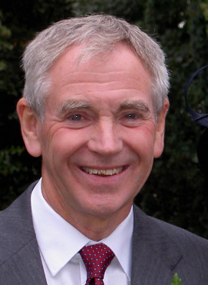

…..cont.

Interesting, on family holidays they used to take it in turns in the choice of music played in the car and Rachel remembers on one occasion listening to the Psalms as they travelled to beach – Dad’s choice!!

At Christ Church Bexleyheath Tony joined the choir singing tenor and bass as needed. It was when David Atkinson, choirmaster at the time, moved to Hitchin in the 1980s, Tony was asked if he would stand in temporarily as choir director for six months. This however lasted around 30 years!!!

Tony brought his flute playing to Christ Church, playing in the band that accompanied the church pantomimes in years past, played lunch time recitals in the church, and in more recent years, the church music group.

In addition to running the choir, Tony ran the Pathfinders Sunday School for several years and led a church house group. He also co-ordinated the Christian Aid collections from the church - Christian Aid has been a charity that was very close to Tony’s heart.

Tony Holcroft died on 29th December 2023 having battled cancer for several years and more recently dementia. As one might expect for such a kind and gentle man, a large congregation attended his funeral on 2nd February at Christ Church.

Doug Snow

**Page 5**

|  |  |  |
| --- | --- | --- |
| **Your Committee** | | |
| Reg. Boulton, President  020 8658 7455 or 07889 172319  reg.boulton@btopenworld.com  Aeron Preston, Vice-president  07775 063987  aeron.glyn.preston@gmail.com  Doug Snow, Treasurer  020 8304 5229  dougsnow.organist@yahoo.co.uk | Melvyn French, Secretary  melvynfrench7@gmail.com  Lydia Gray, Asst. Secretary  01322 551286 or 07426 807758  lg35@lydiagray.plus.com  Barrie Bishop, Ordinary Member  barriebishop2@gmail.com | Bruce Davis, Ordinary Member  01322 558129  bruce.davis11@yahoo.co.uk  Marilyn Downs, Ordinary Member  01322 294569 or 07979 611472  marilyn.downs1950@gmail.com  Peter Mitchell, Ordinary Member  07770 931477  petermit@aol.com |